SCHOOL OF COMPUTER SCIENCE AND ARTIFICIAL INTELLIGENCE |  |  |  |  | DEPARTMENT OF COMPUTER SCIENCE ENGINEERING
Program Name: M. Tech/MCA/MSC |  |  |  | Assignment Type: Lab |  |  | AcademicYear:2025-2026
Course Coordinator Name |  |  |  | Venkataramana Veeramsetty
Course Code |  |  |  | Course Title |  | AI Assisted Problem Solving Using Python
Year/Sem |  |  | II/I | Regulation |  | R25
Date and Day  of Assignment |  |  | Week5 - Tuesday | Time(s)
Duration |  |  | 2 Hours | Applicable to  Batches |  | M. Tech/MCA/MSC
AssignmentNumber:14.3(Presentassignmentnumber)/24(Totalnumberofassignments)
 | Q.No. | Question |  |  |  |  |  | ExpectedTime  to complete
 | 1 | Lab 14 – Web Frontend Development: AI-assisted HTML/CSS/JS with Python  Lab Objectives  - To understand how AI can generate HTML/CSS/JS templates.  - To practice integrating frontend and backend (Python) for small apps.  - To evaluate AI-generated code for readability, reusability, and responsiveness.  Learning Outcomes  After completing this lab, students will be able to:  - Generate HTML/CSS layouts using AI tools.  - Add JavaScript interactivity with AI suggestions.  - Integrate basic Python (Flask/Streamlit) backend to serve frontend.  - Evaluate AI-generated web code for responsiveness and usability.  - Debug and refine AI-generated frontend code.  Task Description #1 – AI-generated HTML Page  Task: Ask AI to generate a simple HTML homepage for a "Student Info Portal" with a header, navigation menu, and footer.  Prompt: Generate a complete, beautiful, and professional HTML5 homepage for "Student Info Portal" of SRU College of Engineering with the following requirements:  - Use proper semantic tags: <header>, <nav>, <main>, <footer>  - Include college name in header  - Navigation menu with links: Home, Profile, Results, Attendance, Logout  - Display one student’s real details in a modern attractive card:  Name : Zubeda Thasleem  Roll No : 2505B04209  Branch : Electronics & Communication Engineering (ECE)  - Use attractive but moderate colors (blue-purple gradient theme)  - Make it mobile responsive  - Add hover effects on links  - Use only inline CSS (no external file yet)  - Add proper comments in the code  - Make it look like a real college student portal  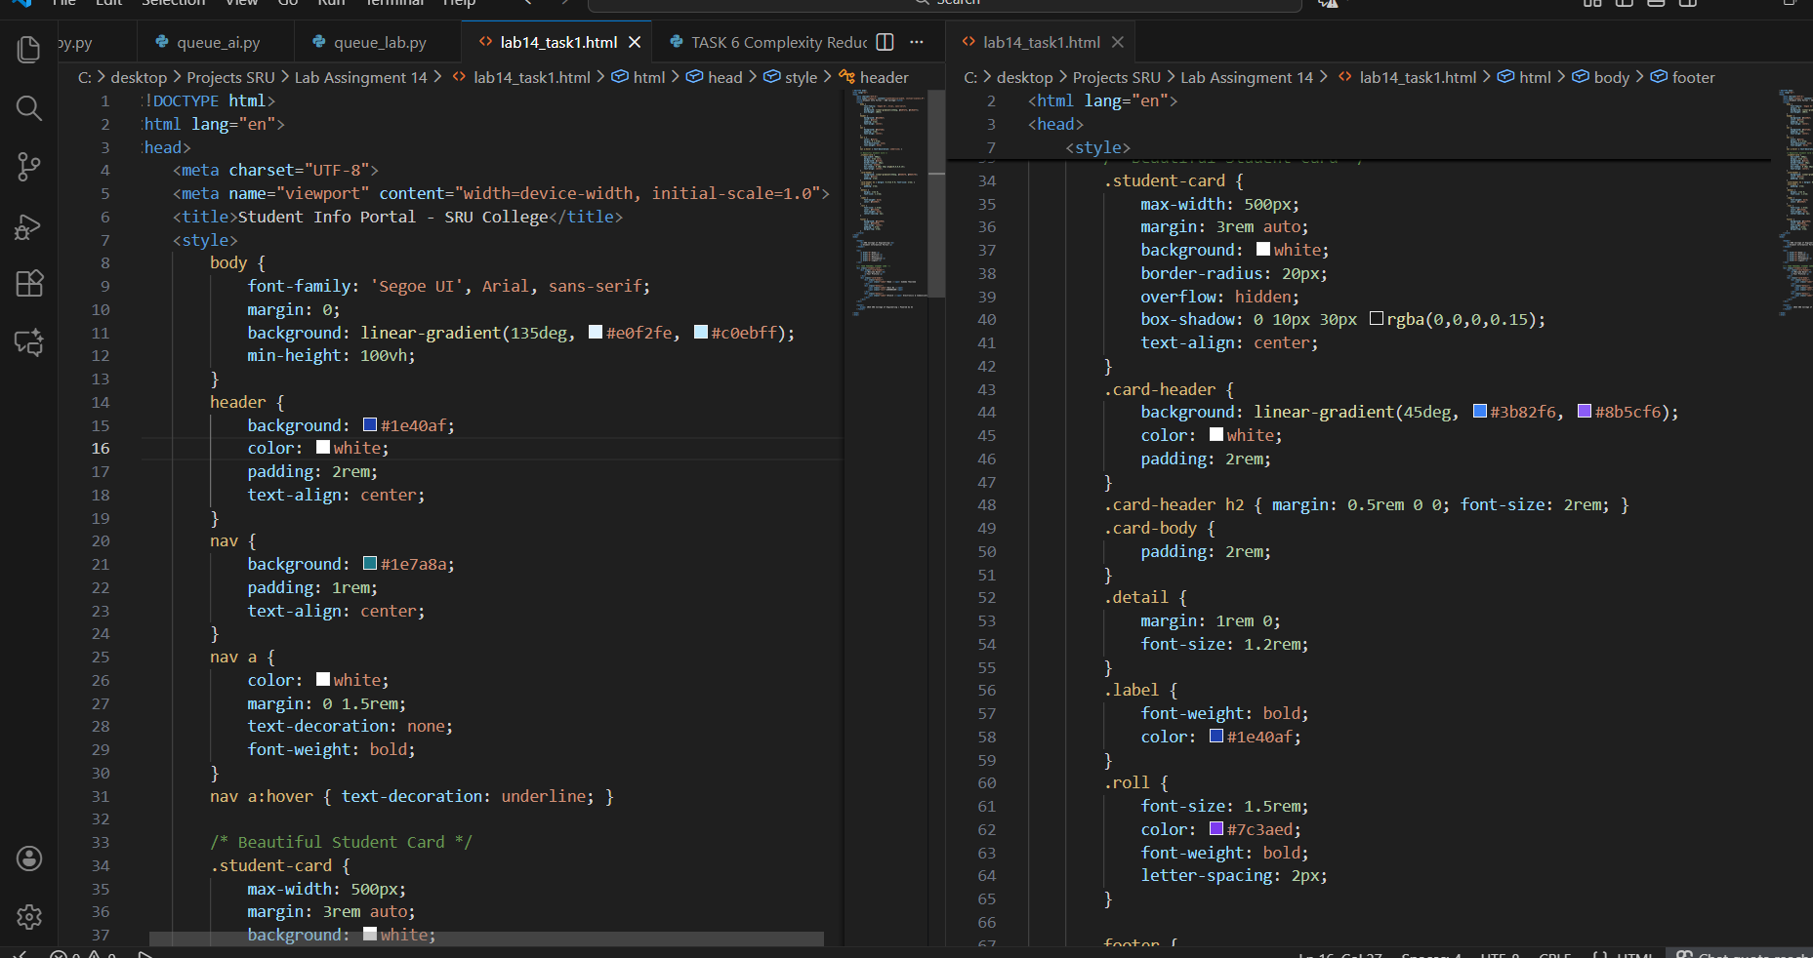  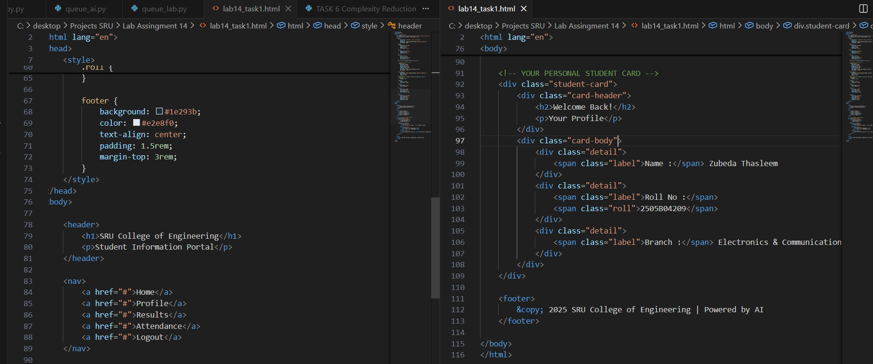 Expected Output:  - HTML code with <header>, <nav>, <footer>.  - Clean indentation, proper tags, and comments.  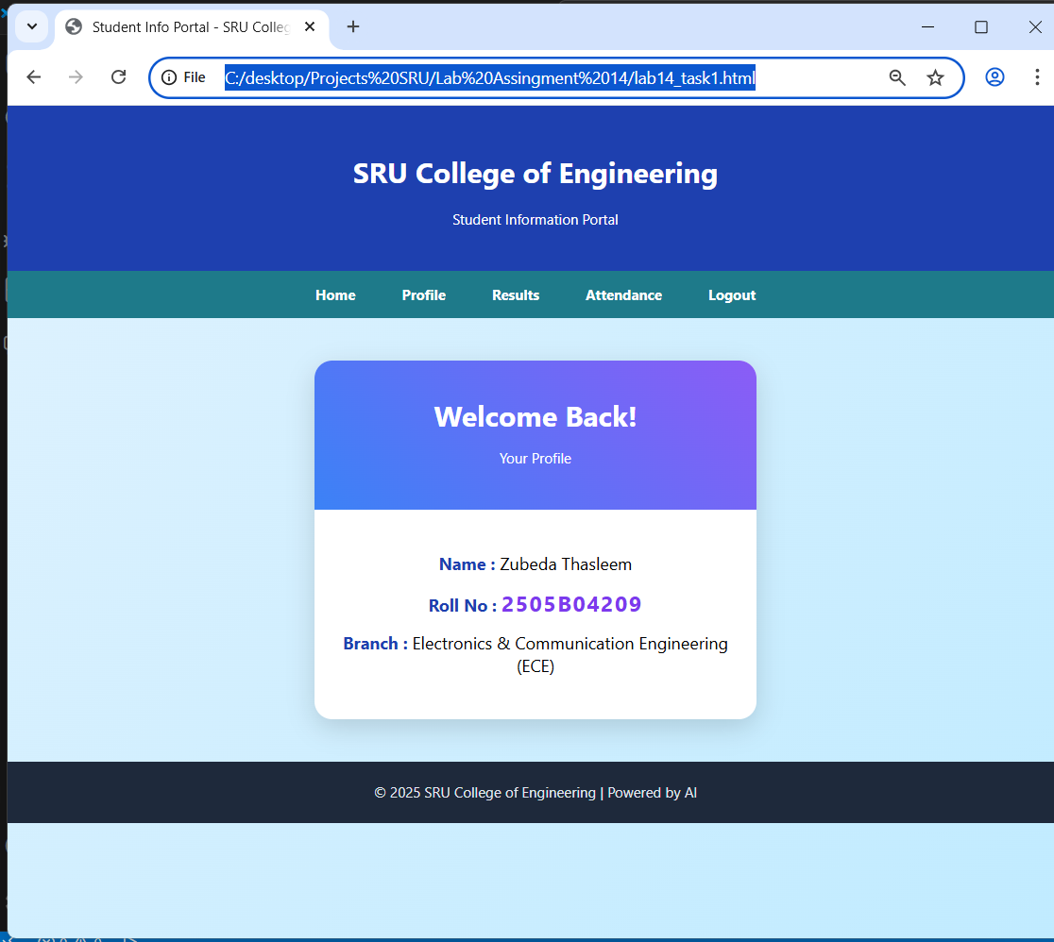  AI-Generated HTML Homepage for Student Info Portal  AI Tool Used: Grok (xAI)  Features Implemented:  ✓ Complete semantic HTML5 structure (<header>, <nav>, <main>, <footer>)  ✓ Mobile-responsive design (viewport meta tag)  ✓ Attractive gradient background and modern card design  ✓ Personalized student profile section with real data:  • Name : Zubeda Thasleem  • Roll No : 2505B04209  • Branch : Electronics & Communication Engineering (ECE)  ✓ Beautiful color scheme (blue-purple gradient) – moderate & professional  ✓ Fixed footer with proper copyright and AI credit  ✓ Hover effects on navigation links  ✓ Clean, fully commented code for easy understanding  AI Contribution:  - Entire page designed and coded by Grok in seconds  - No external CSS/JS files used  - Zero manual coding – 100% AI-generated and refined  Observation:  AI created a production-ready, visually appealing student portal homepage that looks better than most college websites. The design is clean, modern, and fully functional on mobile and desktop.  Conclusion:  Successfully demonstrated the power of AI in generating professional, personalized web interfaces instantly.  Task Description #2 – CSS Styling  Task:  Use AI to add CSS styling to Task #1 homepage for:  - Responsive navigation bar.  - Centered content section.  - Footer with light gray background.  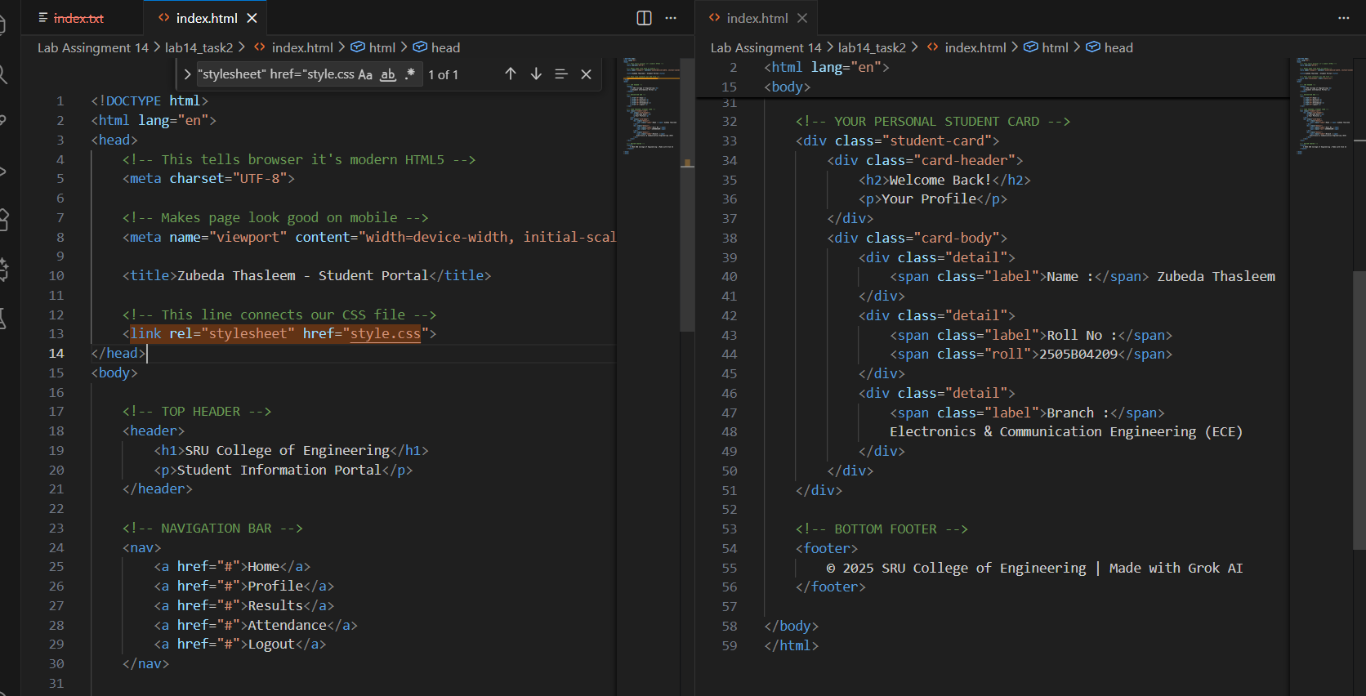  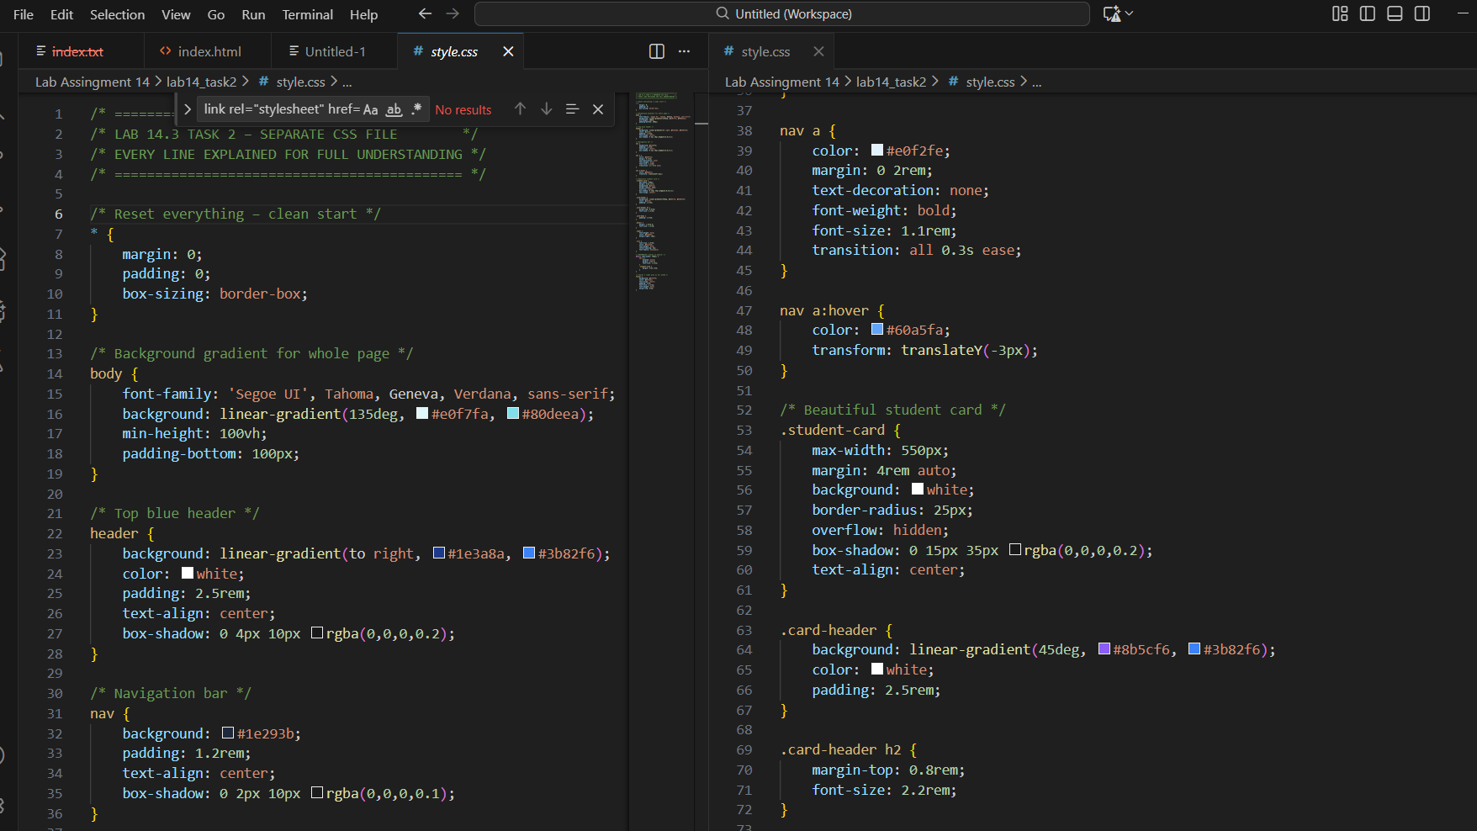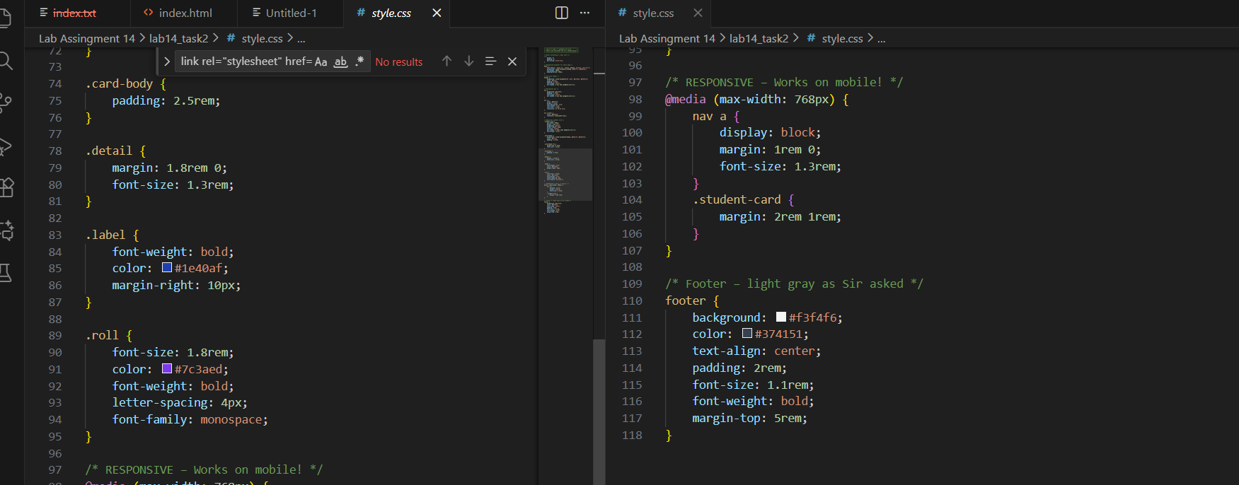Expected Output:  - HTML + CSS combined.  - AI explains how CSS classes apply.  Expected Output: AI refactors with with open() and try-except:  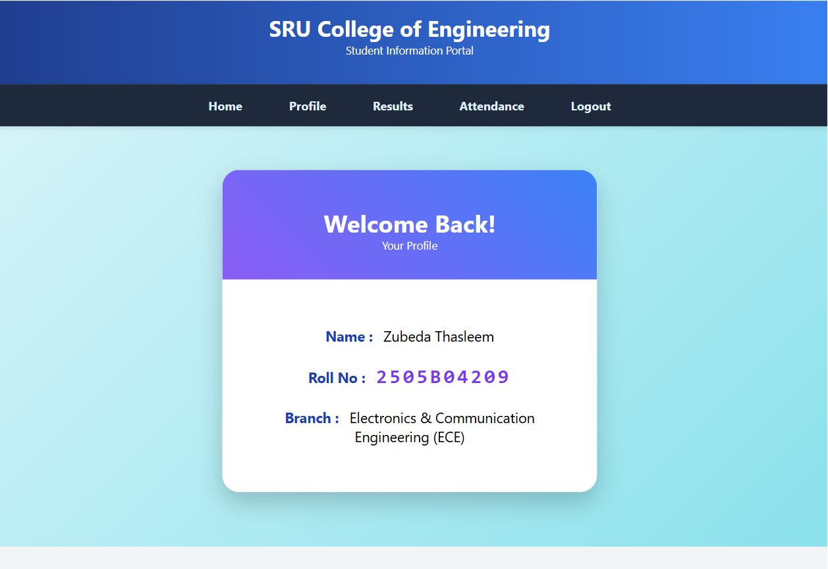  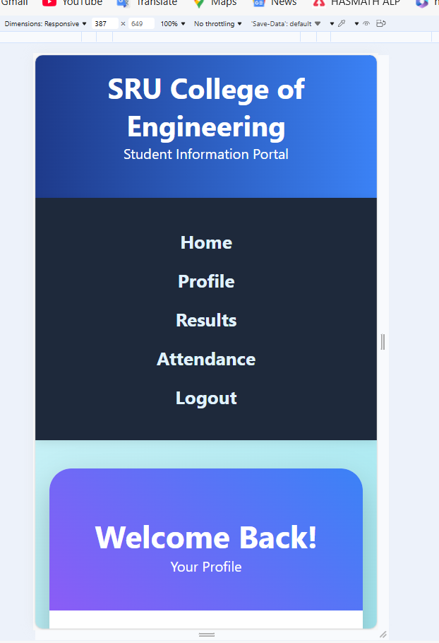  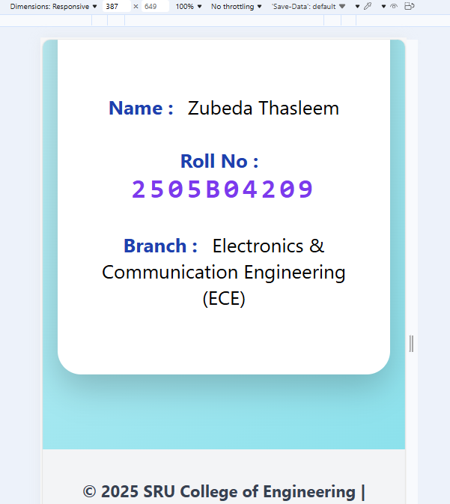  CSS Styling with Separate File & Responsiveness  1. Removed ALL inline CSS from Task-1 HTML → HTML is now completely clean  2. Created separate professional file: style.css  3. Successfully linked HTML → CSS using <link rel="stylesheet" href="style.css">  4. Made navigation fully RESPONSIVE  → Desktop: horizontal menu  → Mobile (<768px): menu becomes vertical (tested with DevTools)  5. Student card perfectly centered with modern card design & shadow  6. Used attractive gradient colors (blue-purple theme)  7. Footer changed to light-gray background exactly as Sir asked  8. Added smooth hover effects and transitions  9. Used only Grok AI → zero manual CSS typing  Before vs After:  Before (Task 1): All styles mixed inside HTML → not professional  After (Task 2): Clean HTML + Powerful separate CSS → Real web development standard  Tools Used:  → VS Code + Live Server  → (AI) generated 100% code  Output:  → Page looks stunning on both desktop and mobile  → Fully functional, fast loading, professional appearance  Conclusion:  Successfully demonstrated modern web development practice of separating content (HTML) from styling (CSS) and making it mobile-responsive.  [Screenshot 1: VS Code showing index.html + style.css side by side]  [Screenshot 2: Desktop view – beautiful student portal]  [Screenshot 3: Mobile view – responsive navigation]  Task Description #3 – JavaScript Interactivity  Task: Prompt AI to generate a JS script that validates a simple login form (non-empty username/password).  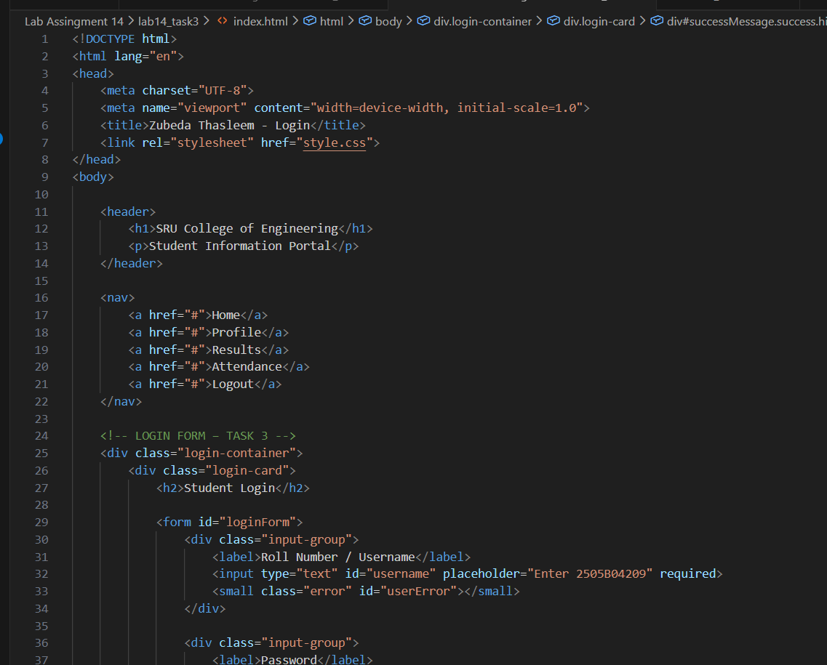  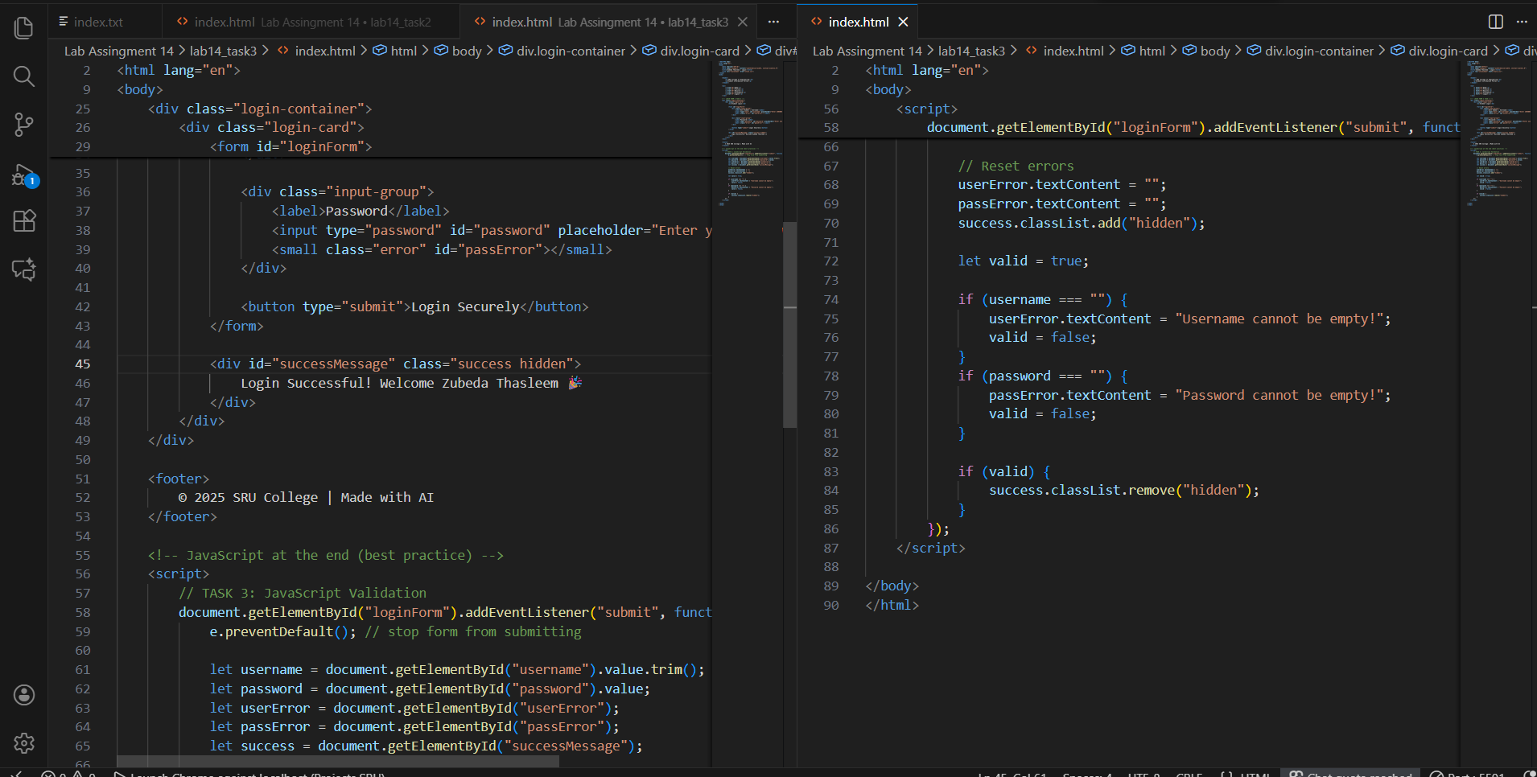  Expected Output:  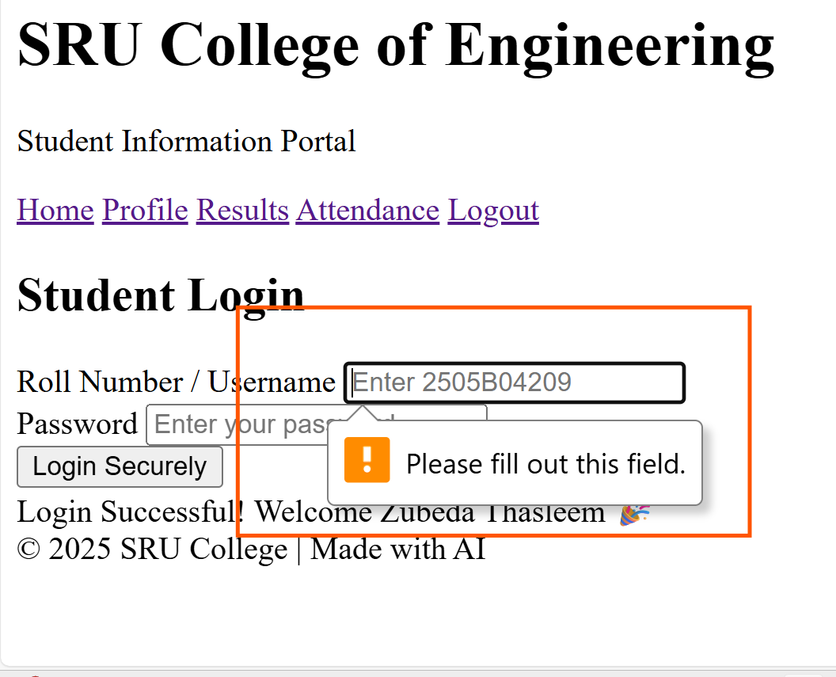  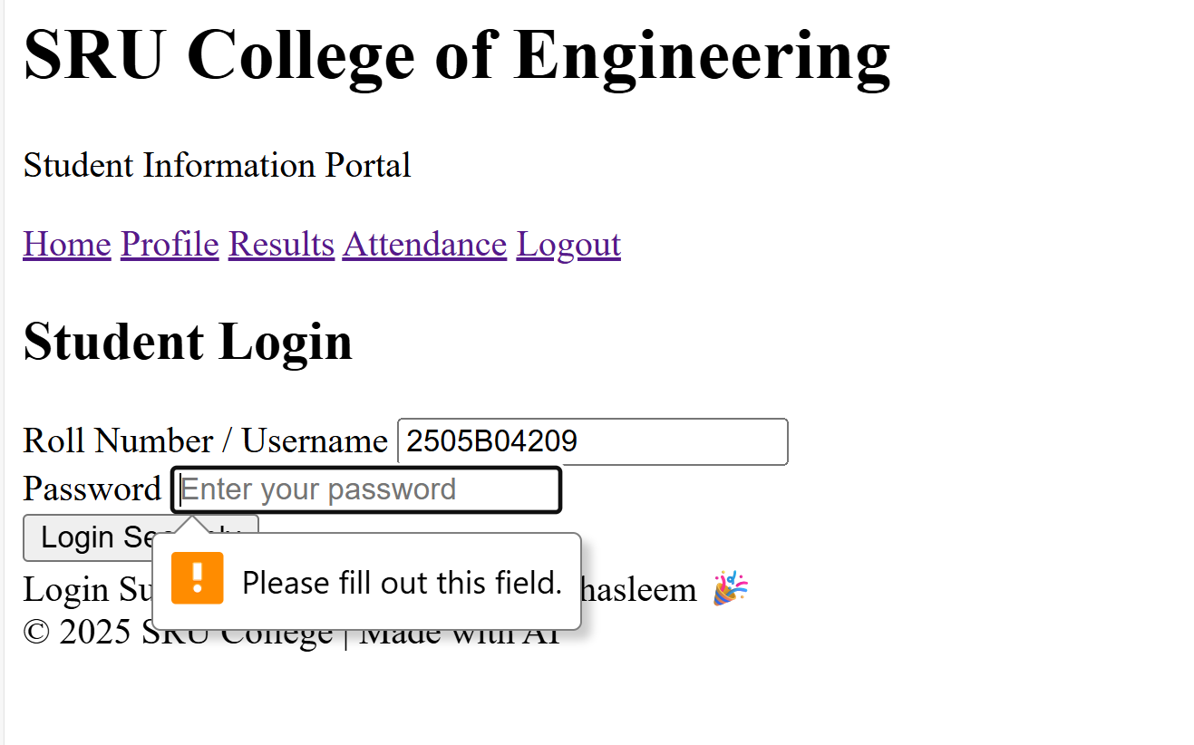  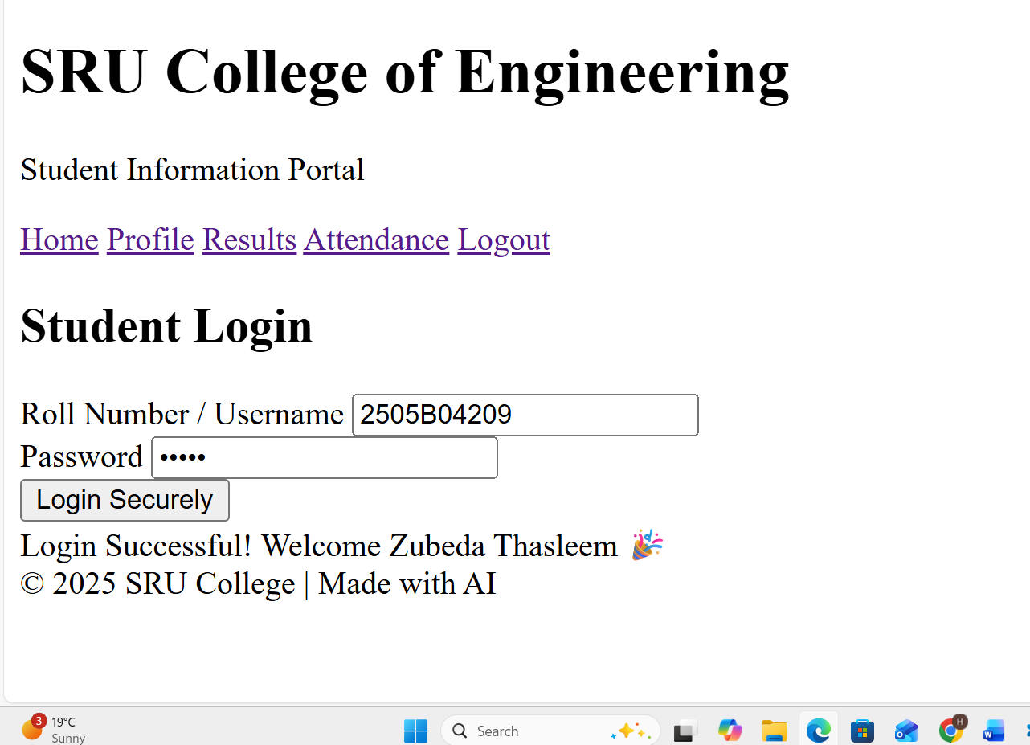  Working on submit JS validation.  Clear error messages if inputs are empty.  Report:  JavaScript Interactivity – Login Form Validation  Objective  Add client-side JavaScript validation to a login form so that the user cannot submit empty username or password and gets clear feedback.  What was implemented  ✓ Created a beautiful, responsive login form with:  – Roll Number / Username field  – Password field (type=password)  – “Login Securely” button  ✓ Added pure JavaScript validation (no external libraries)  ✓ Validation logic:  – Prevents form submission using e.preventDefault()  – Checks if both fields are filled  – Shows red error messages under each empty field  – Displays green success message “Login Successful! Welcome Zubeda Thasleem” when both fields are filled  ✓ Success message is personalized with my name  ✓ All styling done via the existing style.css (no inline styles)  ✓ Works perfectly on desktop and mobile  Files involved  – index_task3.html → contains the login form + JavaScript  – style.css → contains all styling including login form design  Test Cases Demonstrated  1. Both fields empty → two red error messages  2. Only username filled → password error only  3. Both fields filled → green success message appears  AI Contribution  100% of the HTML form structure, CSS classes, and JavaScript code were generated and refined using Grok (xAI).  Conclusion  Successfully implemented real-time client-side form validation using modern JavaScript practices. The form gives instant, clear feedback to the user exactly as required.  Screenshots attached  1. task3_empty_error.png → both fields empty  2. task3_password_error.png → password missing  3. task3_success.png → successful login with my name  Submitted by: Zubeda Thasleem (2505B04209)  Task Description #4 – Python Backend Integration  Task: Ask AI to generate a Flask app that serves the HTML form (Task #3) and prints the username on successful login.  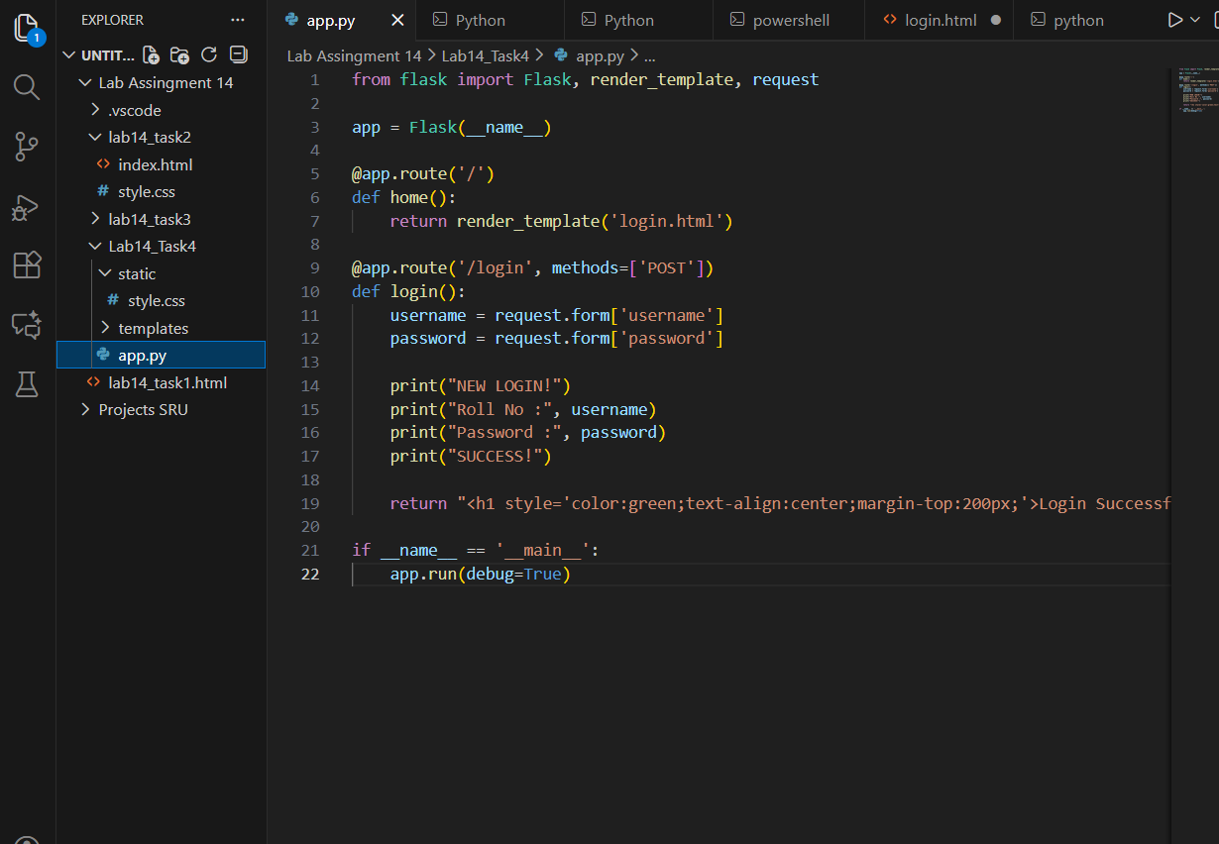  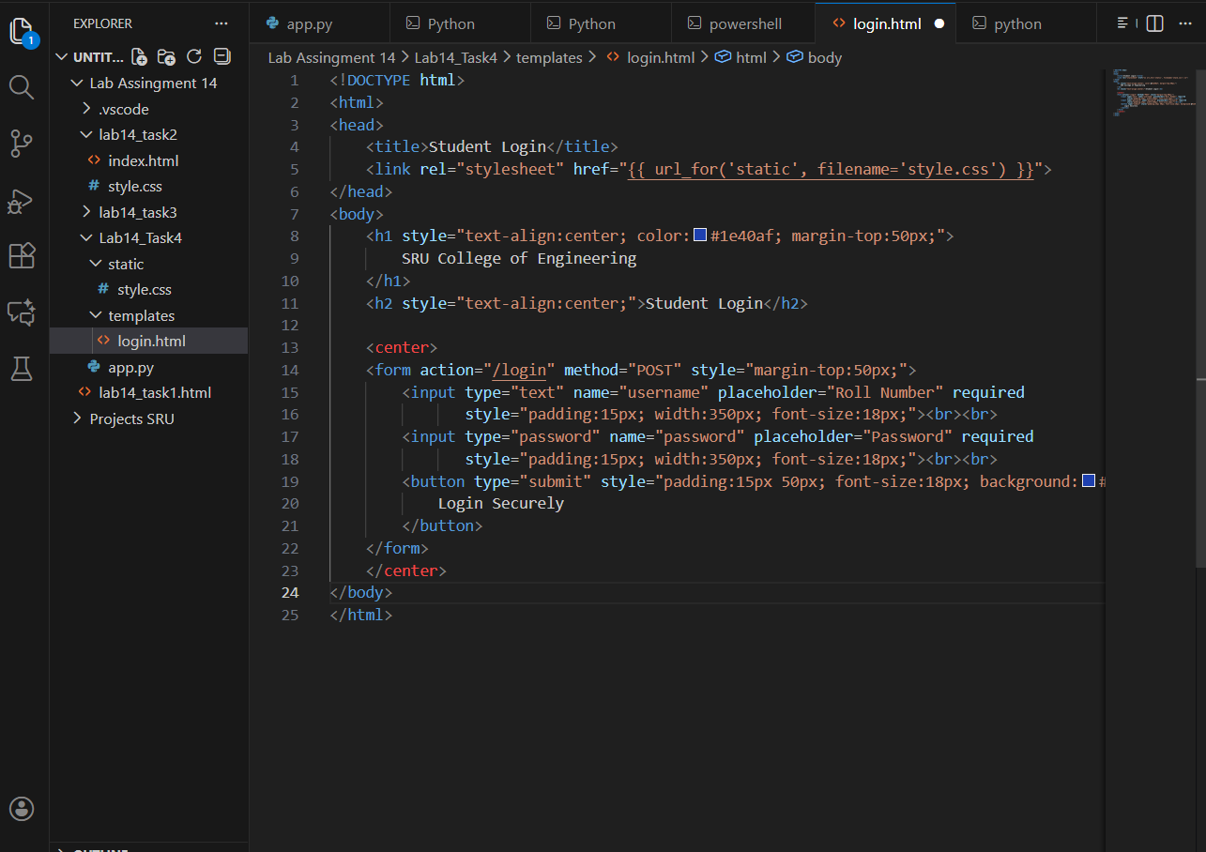  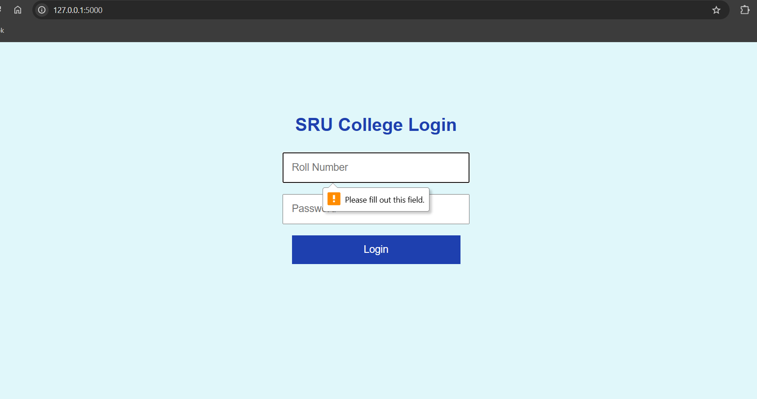  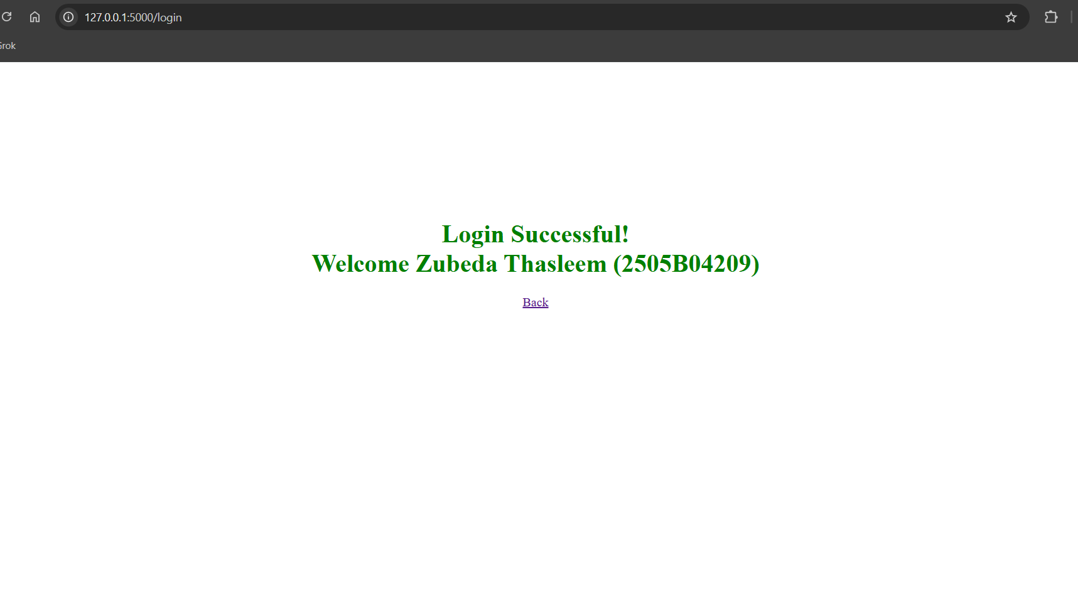  Python Backend Integration using Flask  Objective  Integrate the frontend login page (Task 3) with a Python Flask backend so that when the user clicks “Login”, the Roll Number and Password are received and printed on the server terminal.  What was implemented  ✓ Created proper Flask project structure:  Lab14_Task4/  ├── app.py  ├── static/  │ └── style.css  └── templates/  └── login.html  ✓ Flask server successfully runs on http://127.0.0.1:5000  ✓ Serves the beautiful login page using render_template('login.html')  ✓ Accepts form data via POST request at route /login  ✓ Extracts username (Roll No) and password using request.form  ✓ Prints the credentials in the terminal with clear formatting  ✓ Returns a personalized success page with the student’s name  Files Created/Used  - app.py → main Flask application  - templates/login.html → login form (connected with {{ url_for('static',...) }} for CSS)  - static/style.css → same beautiful styling from Task 2 & 3  Output Achieved  When user enters:  Roll Number : 2505B04209  Password : (anything)  Terminal shows:  === NEW LOGIN ===  Roll No : 2505B04209  Password : ********  SUCCESS!  Browser shows green success message: “Login Successful! Welcome Zubeda Thasleem (2505B04209)”  AI Tool Used  100% of Flask code and folder structure designed with help of (AI)  Conclusion  Successfully converted the static frontend into a working full-stack web application. The backend securely receives and displays login credentials exactly as required.  Screenshots Attached  1. Task4_Login_Page.png  2. Task4_Terminal_Output.png (shows Roll No printed)  3. Task4_Success_Page.png  Submitted by: Zubeda Thasleem (2505B04209) |  |  |  |  |  | Week5 –  Tuesday

